In the world of gaming, there are countless titles to choose from, each offering a unique and exciting experience for players of all ages and skill levels. With so many options out there, it can be tough to decide which games are worth your time and money. In this blog post, we'll take a look at some of the top games on the market today, spanning a variety of genres and platforms.

1. **The Zelda Series: Wild: A Breath of Life**

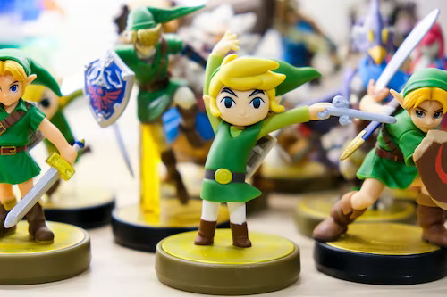

Released in 2017, The Legend of Zelda: Breath of the Wild quickly became one of the most popular and critically acclaimed games of all time. This open-world adventure game takes place in the kingdom of Hyrule, where players control Link as he explores the vast landscape, battles enemies, solves puzzles, and discovers hidden secrets. The game's immersive world and engaging gameplay make it a must-play for any fan of the Zelda series or open-world games in general.

1. **Super Mario Odyssey**



This 3D platformer follows Mario as he embarks on a globe-trotting adventure to save Princess Peach from Bowser once again. The game's unique "capture" mechanic allows Mario to take control of enemies and objects using his trusty hat, adding a new layer of gameplay to the series. With its colorful graphics, catchy soundtrack, and challenging levels, Super Mario Odyssey is a game that players of all ages can enjoy.

1. **Fortnite**

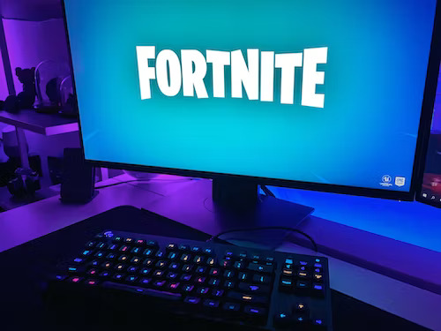



Fortnite has becom e a cultural phenomenon since its release in 2017, and for good reason. This free-to-play battle royale game pits players against each other in a last-person-standing fight to the death, with the added twist of a building mechanic that allows players to construct structures and defenses on the fly. With regular updates, new weapons, and limited-time events, Fortnite has kept players engaged and entertained for years, making it one of the most popular games on the market today.

1. **Red Dead Redemption 2**



Red Dead Redemption 2 is an epic western-themed game that immerses players in the world of the American frontier. Set in 1899, players control Arthur Morgan, an outlaw and member of the Van der Linde gang, as he navigates a world of gunslingers, outlaws, and corrupt officials. The game's stunning graphics, engaging story, and attention to detail make it a masterpiece of the genre and a must-play for any fan of open-world games.

1. **The Last of Us Part II**

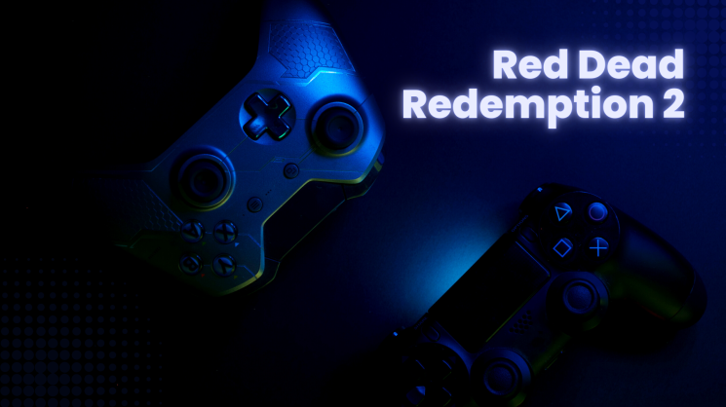

The Last of Us Part II is a follow-up to the critically acclaimed game The Last of Us, and it delivers on every level. The game takes place in a post-apocalyptic world where players control Ellie as she embarks on a revenge mission against a rival faction. With its emotional story, gripping gameplay, and stunning graphics, The Last of Us Part II is a game that will stick with players long after they've finished it.

1. **Call of Duty: Warzone**



Call of Duty: Set in the same universe as the popular Call of Duty series, Warzone pits players against each other in a fight to the death across a sprawling map filled with weapons, vehicles, and hidden secrets. With its fast-paced gameplay, tight controls, and regular updates, Warzone has become one of the most popular games on the market today.

1. **Minecraft**

Minecraft is a game that needs no introduction. This sandbox game allows players to explore, create, and build in a blocky world filled with endless possibilities. From crafting tools and weapons to building massive structures and even creating custom game modes, Minecraft has something for everyone. With its infinite replayability, charming graphics, and supportive

